Experiment No: 04 Machine Learning

Aim:
Train a Linear Regression model on Boston Housing Data, visualizing residuals vs predictions.

Objective:
- To understand linear regression modeling on real-world datasets.
- To train a regression model using the Boston housing dataset.
- To visualize residuals and predictions for evaluating model performance.

Prerequisites:
- Software: Python 3.x with libraries: numpy, pandas, matplotlib, seaborn, scikit-learn.
- Hardware: A computer with at least 4GB RAM.
- Skills: Basic Python programming and knowledge of regression models.
- Dataset Availability: Boston Housing dataset (CSV format).

Theory:
Linear Regression is one of the simplest supervised machine learning algorithms used for predicting a dependent variable based on one or more independent variables. The Boston Housing dataset contains information on housing prices and several features such as crime rate, number of rooms, and distance to employment centers. By fitting a linear regression model, we can estimate housing prices and evaluate model performance using residuals (the difference between actual and predicted values). Visualizing residuals against predictions helps check model assumptions and detect patterns indicating poor fit or non-linearity.

Apparatus / Software Requirements:
- Python IDE or Jupyter Notebook
- Boston Housing dataset (CSV)
- Internet connection for installing libraries (if required)

Procedure:
Step 1: Import required libraries (numpy, pandas, matplotlib, seaborn, scikit-learn).
Step 2: Load the Boston Housing dataset into a DataFrame.
Step 3: Explore the dataset and visualize feature-target relationships.
Step 4: Split the data into training and testing sets.
Step 5: Train a Linear Regression model using training data.
Step 6: Evaluate model predictions using Mean Absolute Error (MAE).
Step 7: Visualize Actual vs Predicted values and plot residuals vs predictions.

Program Code:
# Importing required libraries
import numpy as np
import pandas as pd
import matplotlib.pyplot as plt
import seaborn as sns
# Importing scikit-learn modules
from sklearn.model_selection import train_test_split
from sklearn.linear_model import LinearRegression
from sklearn.metrics import mean_absolute_error
# Load Boston Housing dataset
df = pd.read_csv("Boston_housing_data.csv")
df.head()
# Scatter plot: Number of Rooms (rm) vs House Price (medv)
plt.figure(figsize=(10,8))
sns.scatterplot(data=df, x="rm", y="medv", color="red")
plt.title("Number of Rooms vs Price of House")
plt.show()
# Selecting features and target
X = df.drop("medv", axis=1)
y = df["medv"]
# Splitting the data into train and test sets
X_train, X_test, y_train, y_test = train_test_split(X, y, test_size=0.2, random_state=42)
# Initialize and train the Linear Regression model
model = LinearRegression()
model.fit(X_train, y_train)
# Predicting on test data
y_pred = model.predict(X_test)
# Mean Absolute Error
MAE = mean_absolute_error(y_pred, y_test)
print("Mean Absolute Error:", MAE)
# Plot Actual vs Predicted values
plt.scatter(y_test, y_pred, color="red")
plt.plot([y_test.min(), y_test.max()], [y_test.min(), y_test.max()], color="black", linewidth=4, label="Perfect Prediction")
plt.title("Actual vs Predicted Values")
plt.xlabel("Actual")
plt.ylabel("Predicted")
plt.legend()
plt.grid(True)
plt.show()

Expected Output:

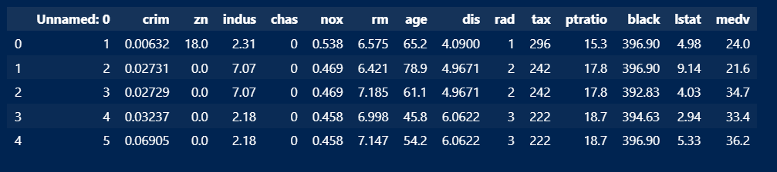
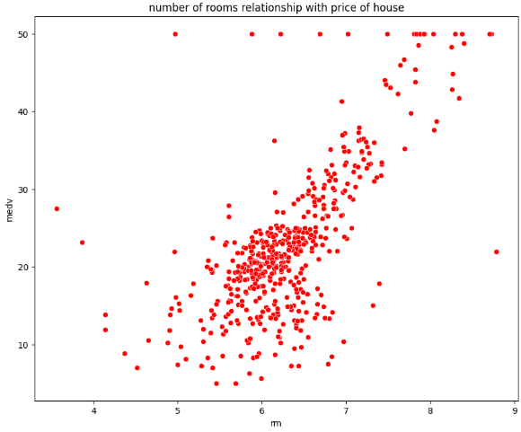

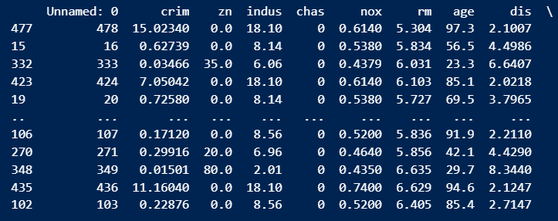

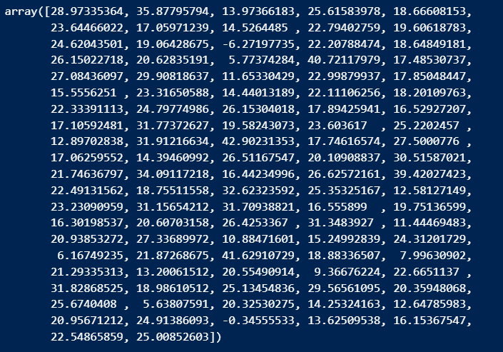

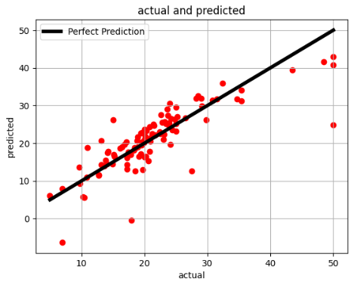

Observations:
The linear regression model predicts housing prices with varying accuracy depending on the features. Residual plots help assess whether the model assumptions hold and highlight any non-linearity or heteroscedasticity.

Conclusion:
This experiment demonstrates the application of Linear Regression on the Boston Housing dataset. The model provides reasonable predictions, and visualization of residuals helps analyze model performance and possible improvements.

Viva Questions:
- What are residuals in regression analysis?
- Why is it important to visualize residuals vs predictions?
- How can overfitting be detected in regression models?
- What other metrics can be used to evaluate regression performance apart from MAE?

